Beta ratio effects on skewed inverter.
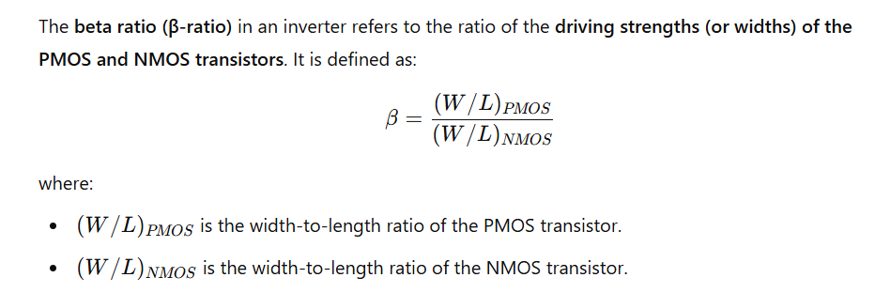
Effects of Beta Ratio on a Skewed Inverter
A skewed inverter is one where the PMOS and NMOS transistors have significantly different sizes, resulting in asymmetric rise and fall times.
- Increase in β (Strong PMOS, Weak NMOS)
  - The pull-up strength increases, meaning the high-to-low transition is slower.
  - The fall time (t_f) increases, and the rise time (t_r) decreases.
  - The noise margins shift, making the inverter more resistant to noise when transitioning from low to high.
  - This configuration is useful for circuits where pulling up faster is crucial, such as dynamic logic.
- Decrease in β (Weak PMOS, Strong NMOS)
  - The pull-down strength increases, meaning the low-to-high transition is slower.
  - The rise time (t_r) increases, and the fall time (t_f) decreases.
  - The switching threshold moves lower, making it more responsive to high-level input changes.
  - This configuration is often used in cases where fast pull-down is needed, like in clocked circuits.
Trade-offs and Design Considerations
- Power Consumption: A higher β-ratio means a stronger PMOS, leading to increased static power consumption.
- Switching Speed: If the skew is too strong in one direction, the overall inverter delay may increase.
- Propagation Delay: The inverter's speed depends on whether it is skewed towards pull-up or pull-down, affecting circuit timing.

How does channel length modulation affect the drain current in short-channel MOSFETs?
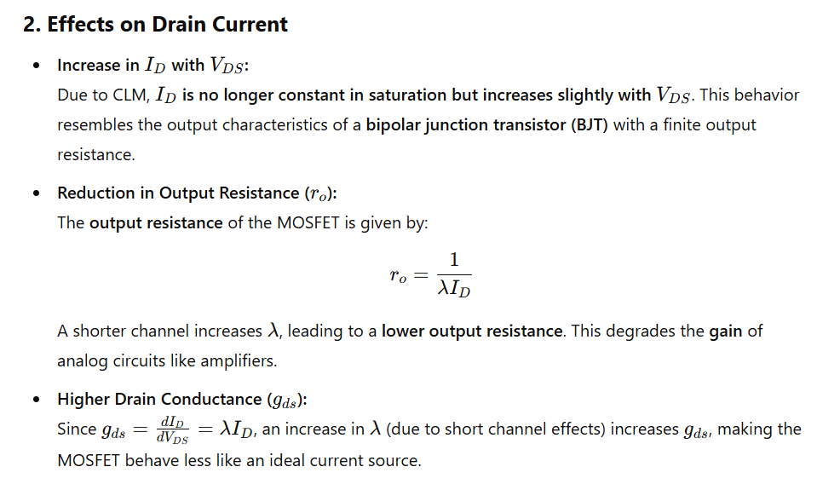3. Impact on Short-Channel Devices
In deep-submicron and nanoscale MOSFETs:
- CLM becomes more significant due to the reduced channel length.
- Device characteristics deviate from ideal models, requiring additional corrections.
- Leakage currents and variability increase, affecting digital and analog circuit performance.
Conclusion
Channel length modulation causes a nonzero output conductance, reducing the output resistance and causing the drain current to increase slightly with VDSV_{DS}VDS​ in saturation. This effect is more pronounced in short-channel MOSFETs, impacting analog circuit performance, gain, and linearity.

8. Explain the impact of leakage current on power dissipation in CMOS circuits.
- Leakage Power Dissipation: Even when a transistor is supposed to be in an off state, a small amount of current still flows through it due to insufficient insulation, known as leakage current. As the number of transistors on a chip increases, the total leakage current increases, leading to leakage power dissipation.
- 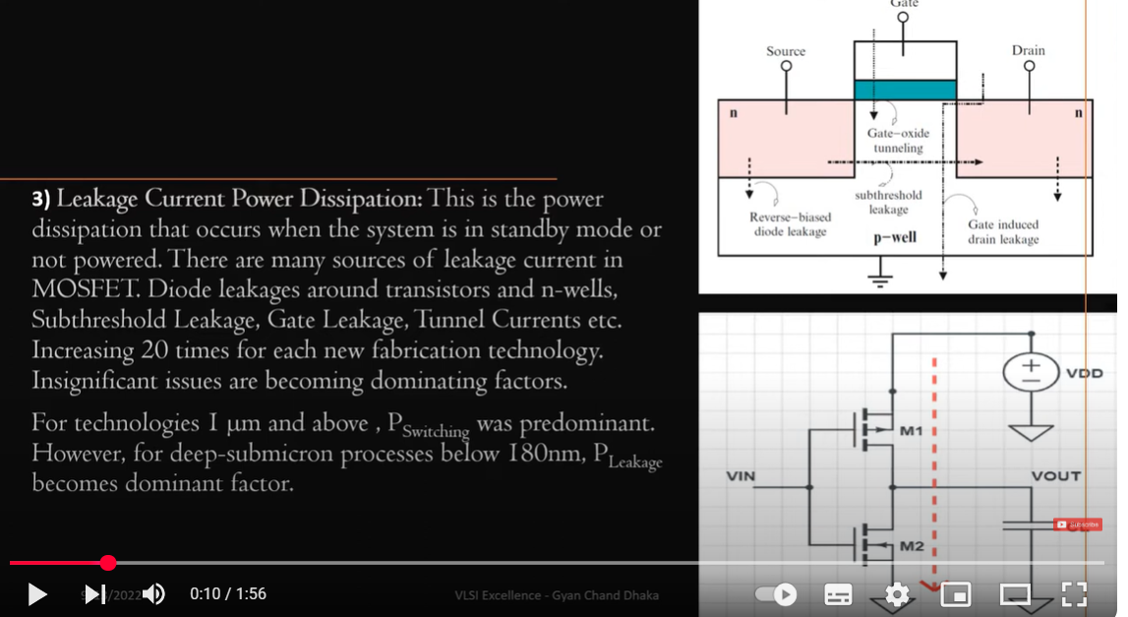
10. How does the beta ratio affect the noise margins and switching threshold of a skewed inverter?
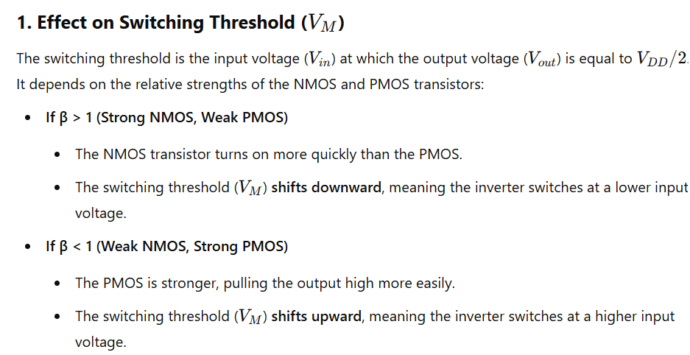

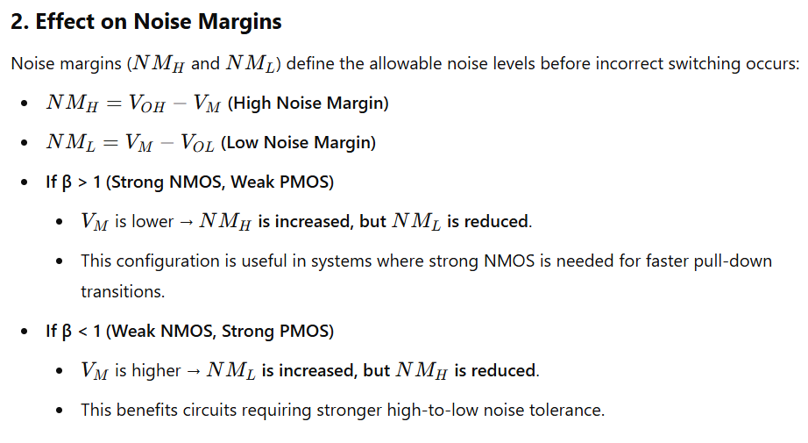
Transfer characteristics of cmos
https://vlsi-teacher.blogspot.com/2016/02/cmos-inverter-voltage-transfer.html

